Book Recommendation System

1. Introduction: In our current world, we have lots of kinds of recommendation system like food, cloth, etc. Every system utilizes the user data and generates proper response. In order to process such huge amount of data we need expert systems which can learn from user behavior. Now-a-days AI is everywhere. So to familiarize ourselves to the state of the art of AI we used logical programming language like prolog to develop our project.
2. Design: The Book Recommendation System is designed into two parts. In one part, the system recommend genres based on the age and mood of the user. Picture is shown below:

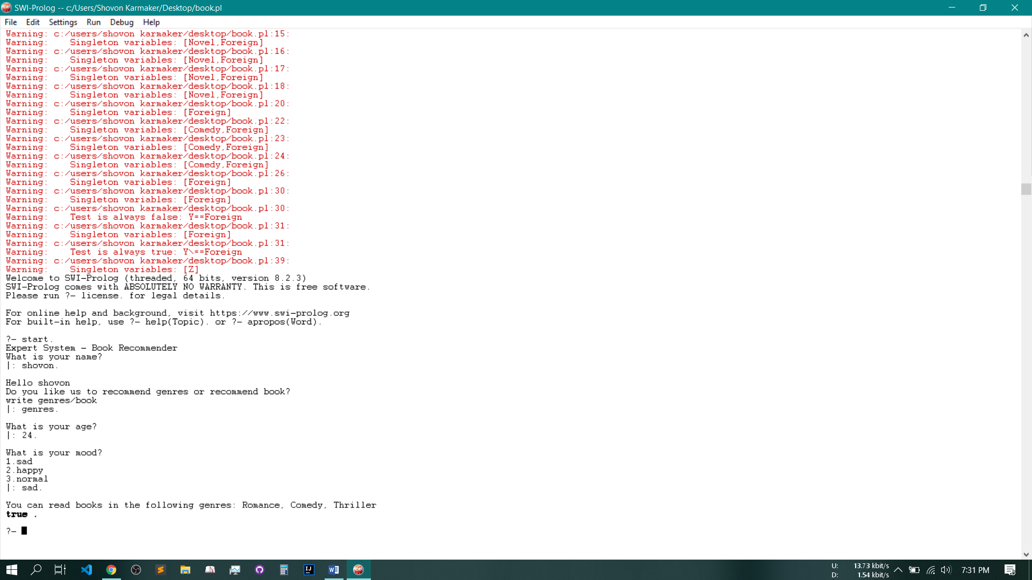

Figure Genre recommendation

If a user is below 18 years the expert system will suggest Child Story to him.

Another part of our system is to recommend books to the user.

The system can recommend books using genres or the book’s writer. The picture is shown below:

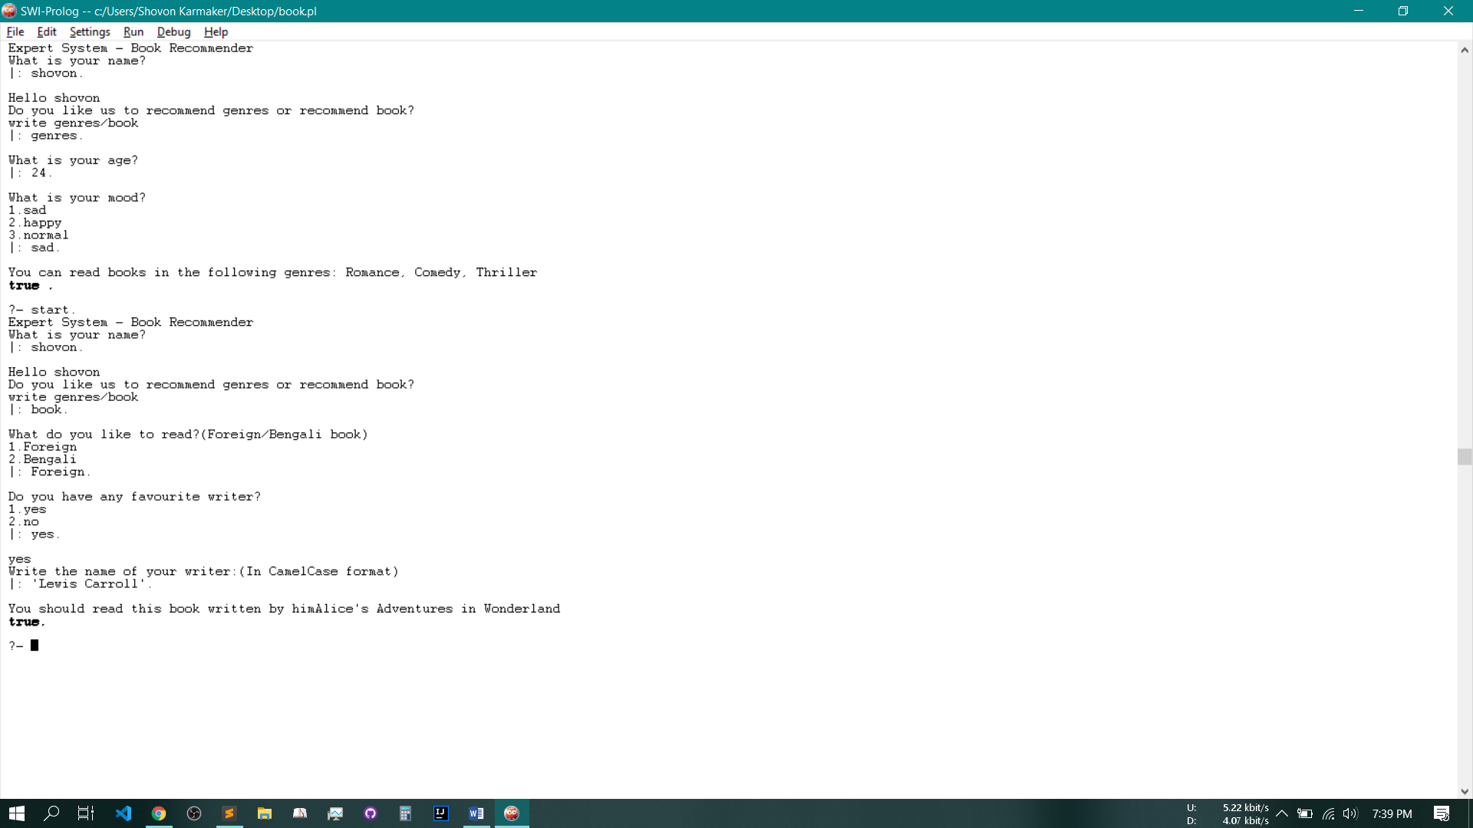

Figure Book Recommendation using writers name

In this part, the system recommends book based on the language of the book and the writer’s name of the book. If the writer’s name is not in the knowledge base then the

There is another part in this system. This part recommends book based on the language and genre of the book. Picture is shown below:

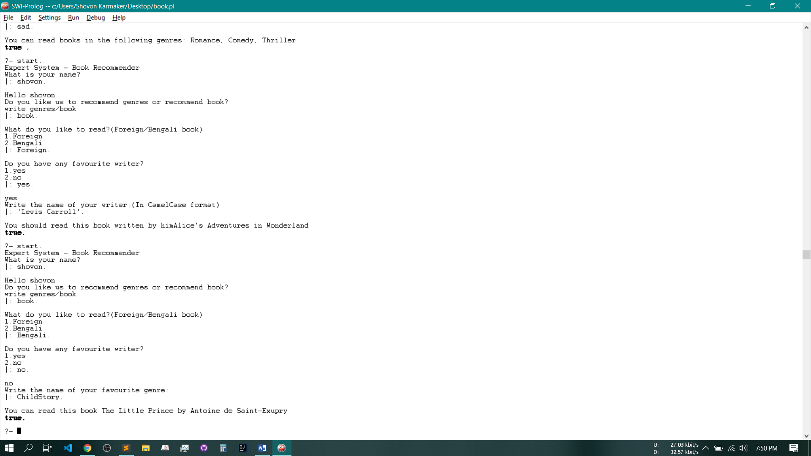

Figure Book Recommendation using genre.

1. Methodology: The code is divided in to several parts. The first part is the knowledge base. The knowledge base is shown below:

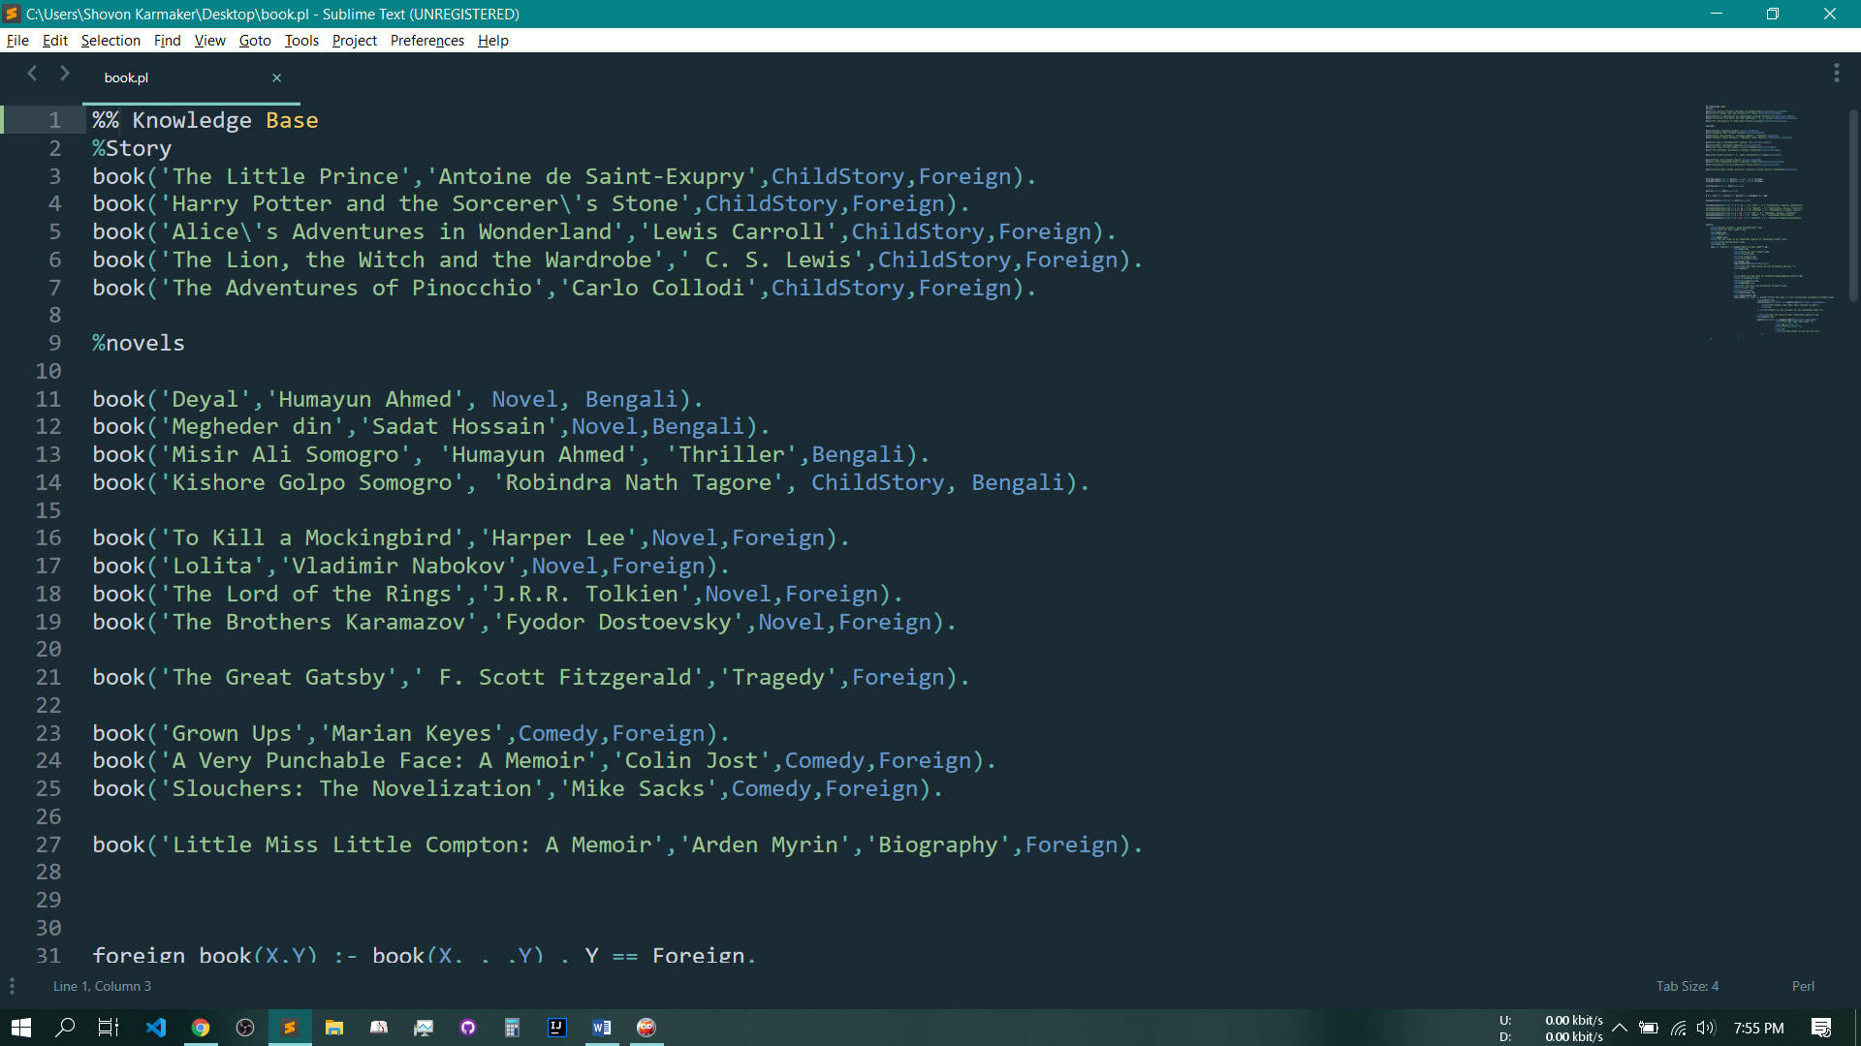

Another part is rules of the system. The rules of the system is shown below:

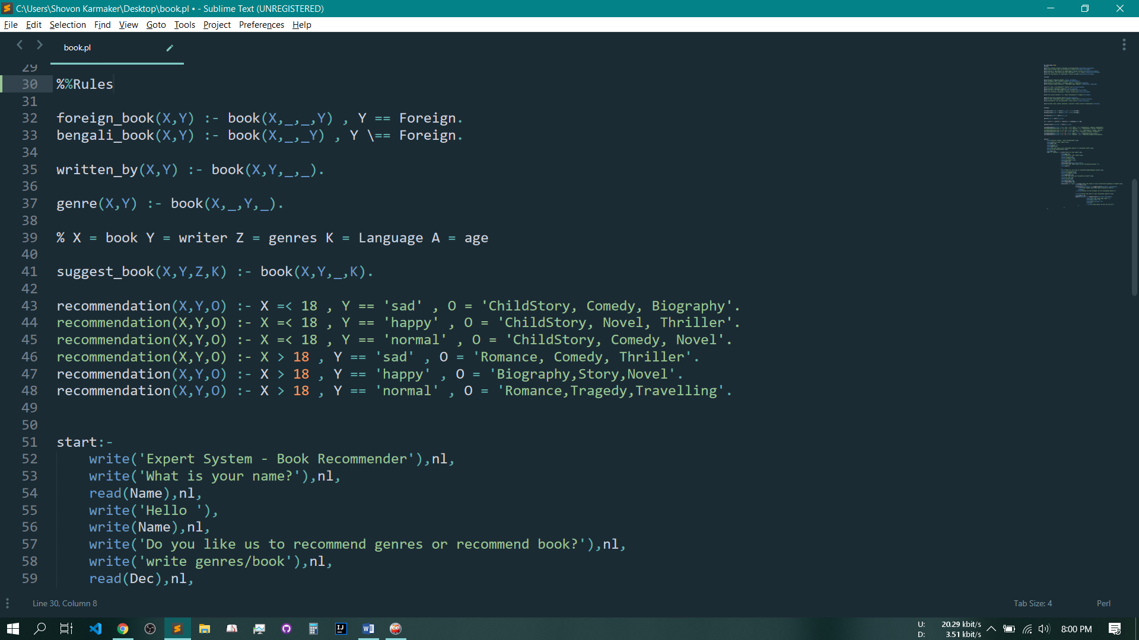

Expert System is shown below:

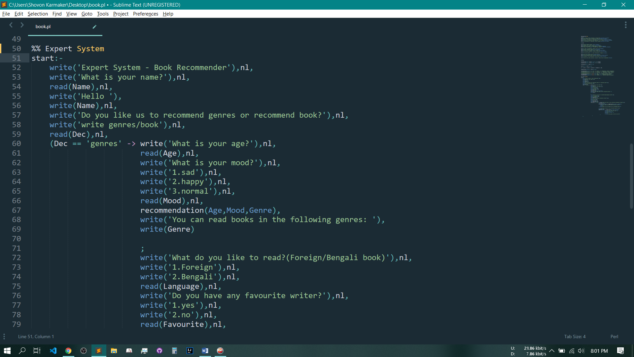

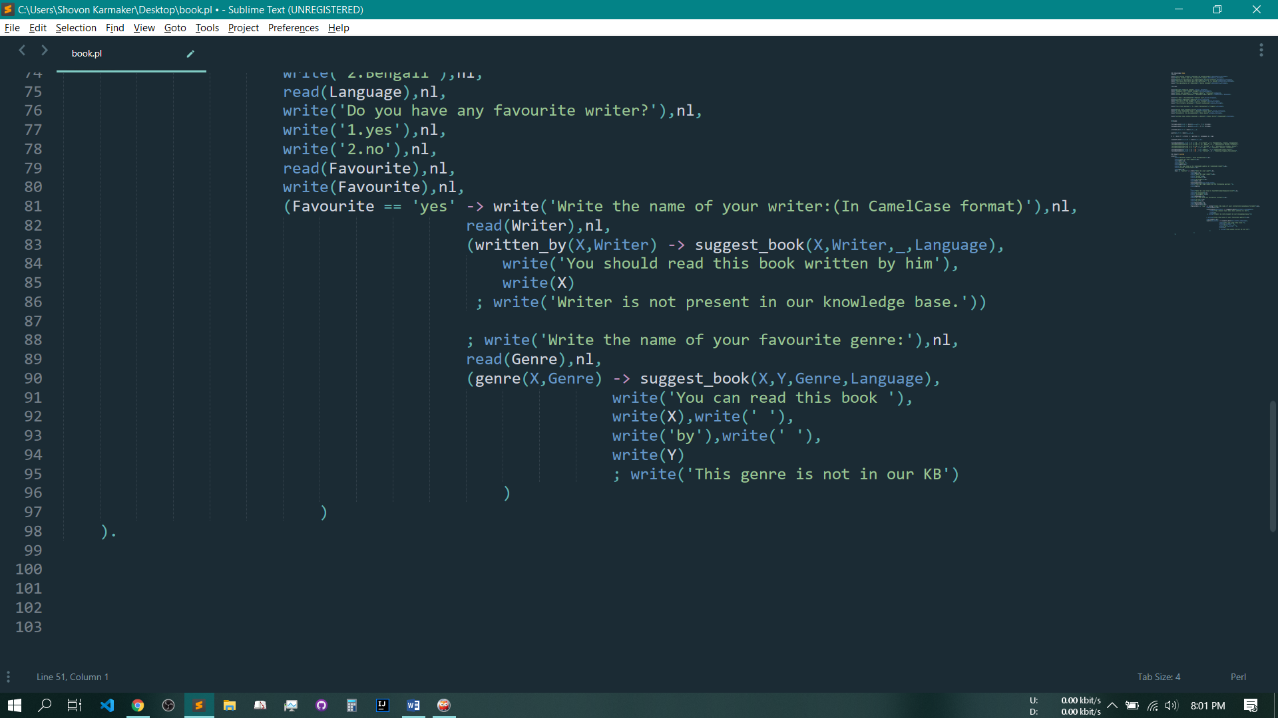

1. Conclusion: The objective of this project is to build an expert system that can recommend books depending on small number of factors.

In future, we may build a robust system depending on a large number of factors.